**TEST CASE : ASSIGNMENT 6**

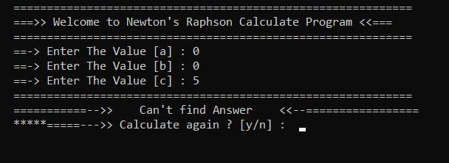

Case 1 : a = 0, b = 0, c = 5

Case 2 : a = 0, b = 5, c = 4

Case 3 : a = 2, b = 5, c = 2

Case 4 : a = 2 , b = 2, c = 5

Case 5 : a = 1 ,b = -2, c = 1

Case 6 : a = 1, b = -1, c = 1